**Gym Management System**

You have to develop Gym management system to manage Gym member records. Features of member and administrator are given below. You have to implement these features in 8086 Assembly language with the help of procedures and stack. These features are mandatory and carry marks. If you want to add other features to your project then you can add.

|  |  |
| --- | --- |
| **Features of the  (Member)** | **Features of the Administrator** |
| Pay fee | Add a member |
| View details | Delete a member |
| Update profile | Display member details |
|  | Search for a member |

**Welcome Screen**

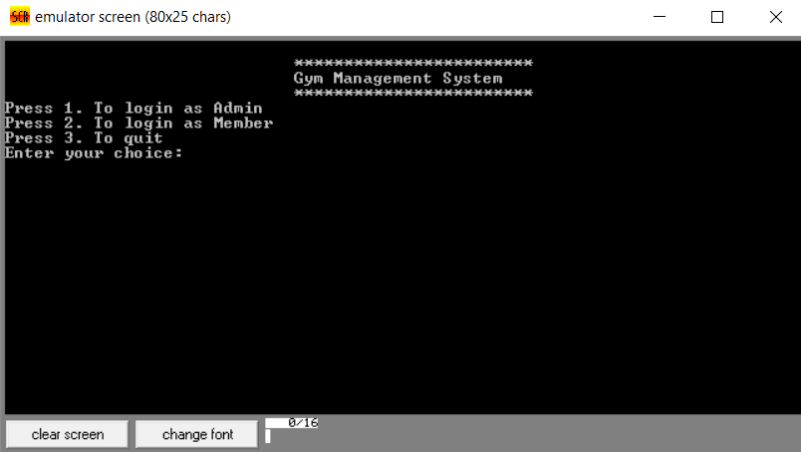

1. **If user selects option 1, then show Admin login screen.**
2. **If user selects option 2, then show member screen.**
3. **If user selects option 3, then terminate the program.**
4. **If user enter an invalid choice then show prompt message “You have entered an Invalid choice...Please enter again” as shown in the given below screen shot.**

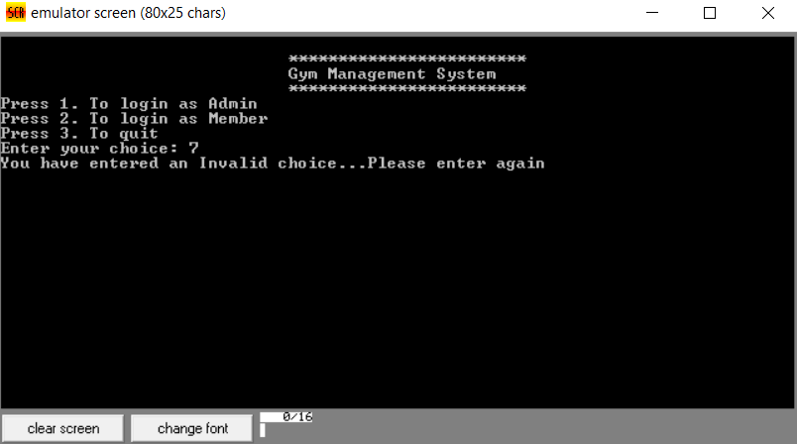

**Administrator Portal**

1. **If user enter correct username and password here then show admin main menu.**
2. **If user enter invalid username or password prompt user “You have entered an invalid username or password...Try again!!! “ as shown in screen shots respectively.**

**Admin Login screen**

**User is entering username and password**

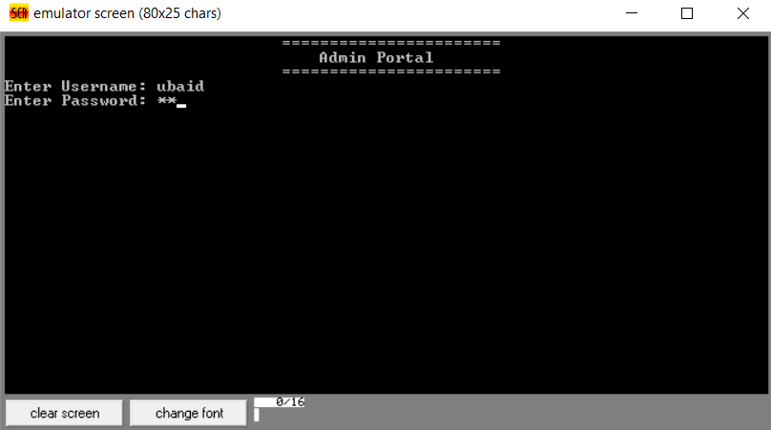

**User has entered correct username and password**

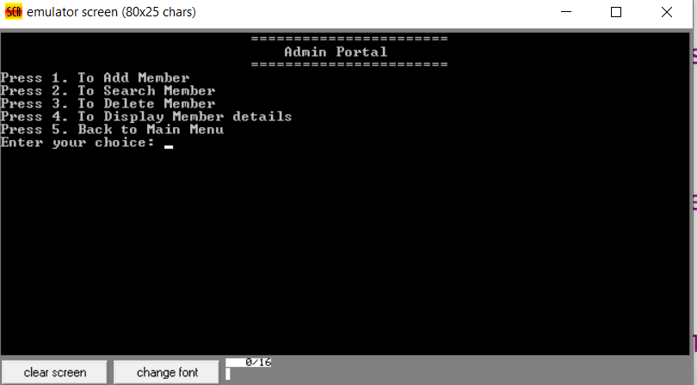

**User has entered incorrect username and password**

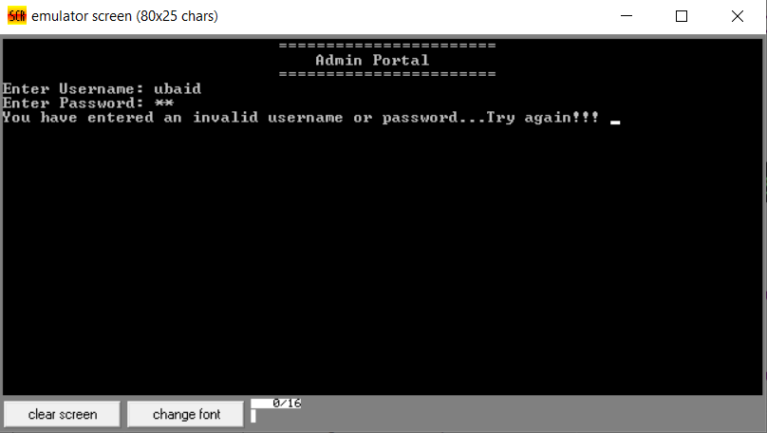

**Validate the input, it should be between 1 to 5 otherwise show message “You have entered an Invalid choice...Please enter again” and again show Admin Portal screen to user.**

1. **If user selects option 1, then show Add member screen with the following menu. As the user enters member name, age and contact# then clear the screen and show again admin main menu**

**Enter Member Name:**

**Enter Age:**

**Enter Contact#:**

**After taking input of member name, age and contact# show message “Member Added successfully”.**

1. **If user selects option 2, then show Search member screen with the following menu.**

**Press 1. To Search by Member contact#**

**Press 2. Back to Admin Menu**

**Enter your choice:**

**Validate the input, it should be between 1 to 2 otherwise show message “You have entered an Invalid choice...Please enter again” and again show search member screen to user.**

**If the user select option 1, here then take input of member contact# and store this input in array and compare this string with already stored string. If they are equal then print “Found” else print “Not found”. You can use linear search or binary search algorithm for searching member record.**

1. **If user selects option 3, then show Delete Member screen. This will delete the member data.**
2. **If user selects option 4, then show Display member screen. It will display member name, age and contact#. If there is no member data, then show message “No record….Found”.**
3. **If the user selects option 5, then show Main Menu screen and the program starts again from beginning.**

**Member Portal**

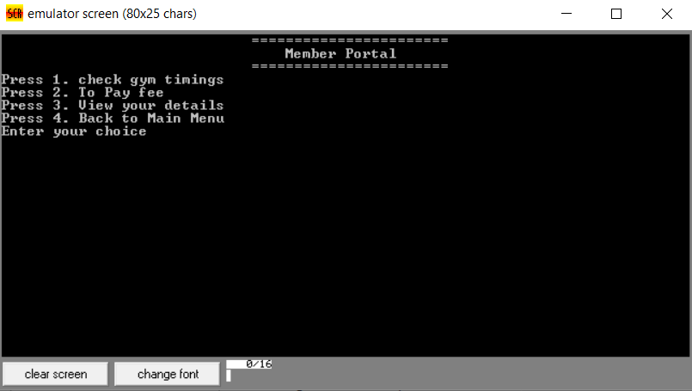

**Validate the input, it should be between 1 to 4 otherwise show message “You have entered an Invalid choice...Please enter again” and again show Member Portal screen to user.**

1. **If user selects option 1, then show gym timings.**
2. **If user selects option 2, then show the following message. If the user successful pays gym fee then show message gym fee paid. If the amount enter is less than or more than gym fee then display appropriate message.**

**Enter Amount:**

1. **If the user select option 3, then print member details like member name, age and contact #.**
2. **If the user selects option 4, then show Main Menu screen and the program starts again from beginning.**